# Java Black Box Testing Screen Dumps

# Test 1

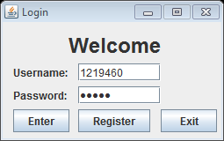Screen ClippingScreen Clipping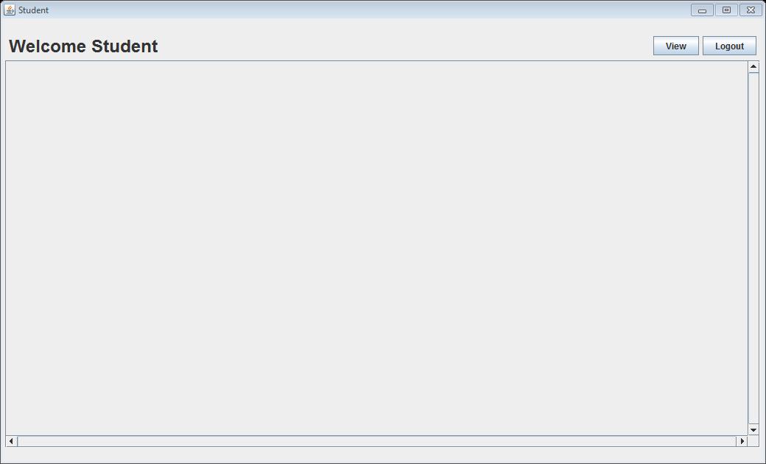

Input corresponds with database records

Successful login to student GUI

# Test 2

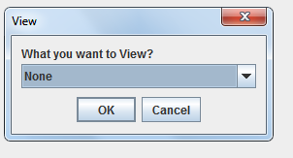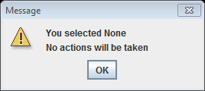

# Test 3

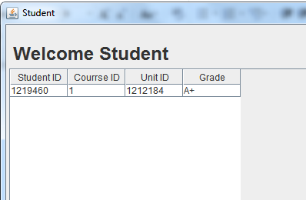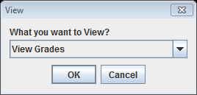

# Test 4

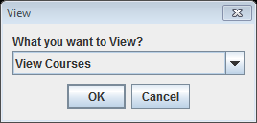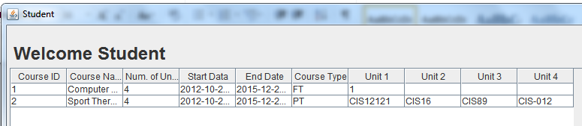

# Test 5

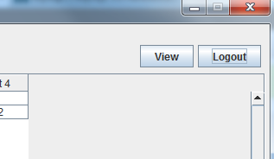

As you can see the logout button is high-lighted

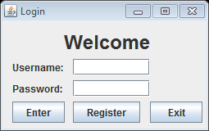

# Test 6

# LoginStudentScreen ClippingScreen Clipping

# Test 7A



Viewing someone else’s grades!!!

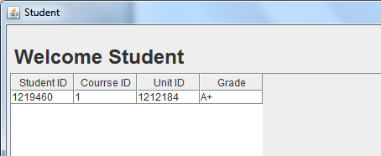

# Test 7B

# LoginScreen ClippingScreen ClippingScreen ClippingScreen ClippingMessageScreen Clipping

User ID

Password

Selecting grades

Reconfirming ID to look at grades

Student main panel

Student grade/s

# Test 8

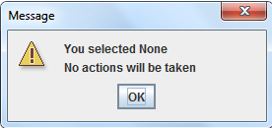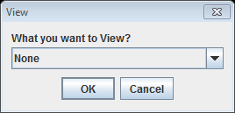

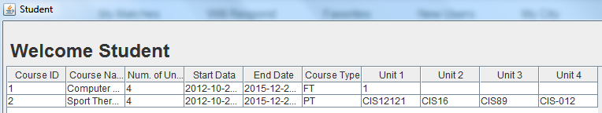

# Test 9A

Displays same information from test 4!!!

# Test 10A

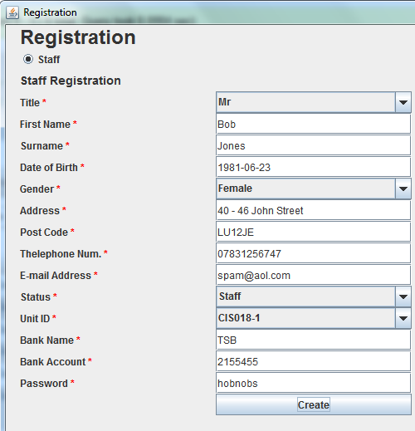

Screen Clipping

Address and gender in the same field!!

# Test 10B

# Screen Clipping

# Test 11

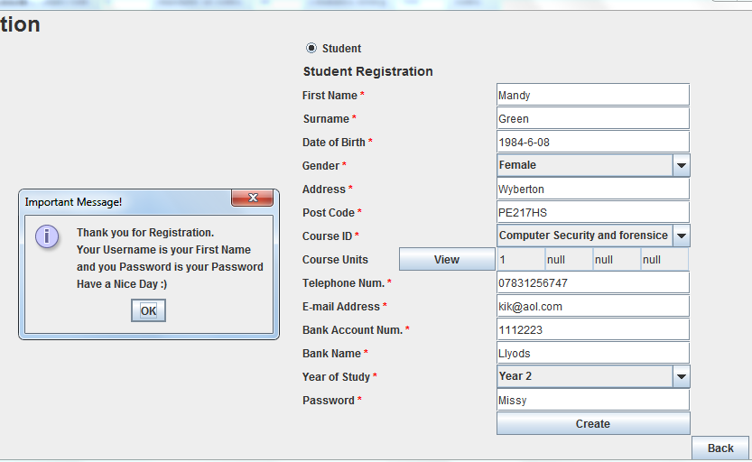

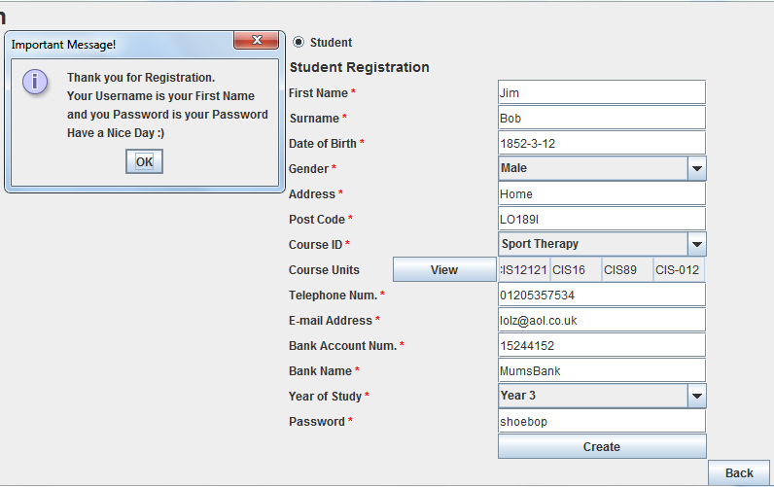

# Test 12

# LoginScreen ClippingScreen ClippingStaff

# Test 13A

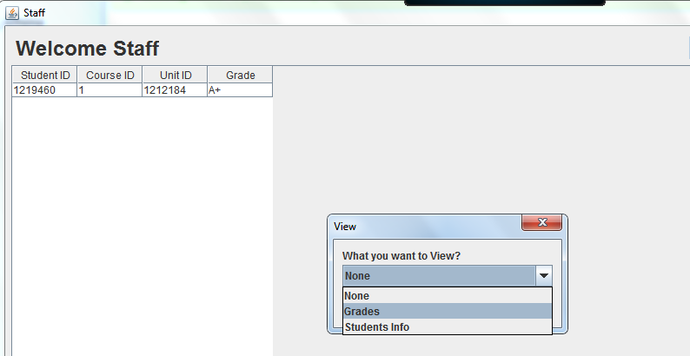

# Test 13B

# LoginScreen Clipping Screen ClippingScreen ClippingScreen Clipping

User ID

Password

Selecting grades

Reconfirming ID to look at grades

Student main panel

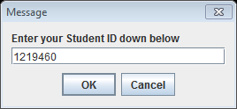

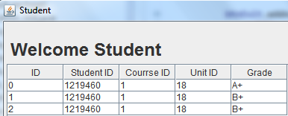

Student grade/s

# Test 14

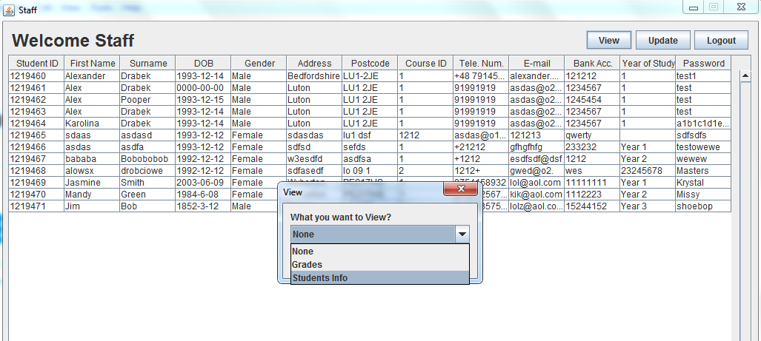

# Test 15

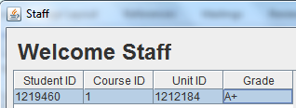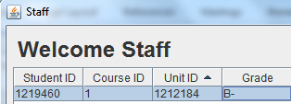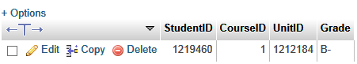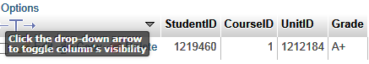

Grades Edited

# Test 16

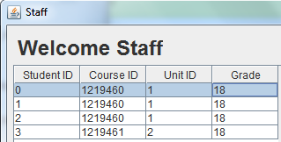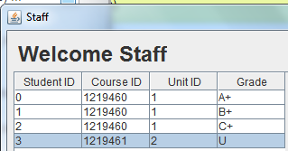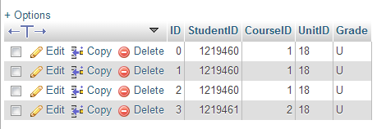

# Test 17

Screen ClippingScreen Clipping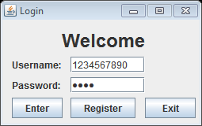

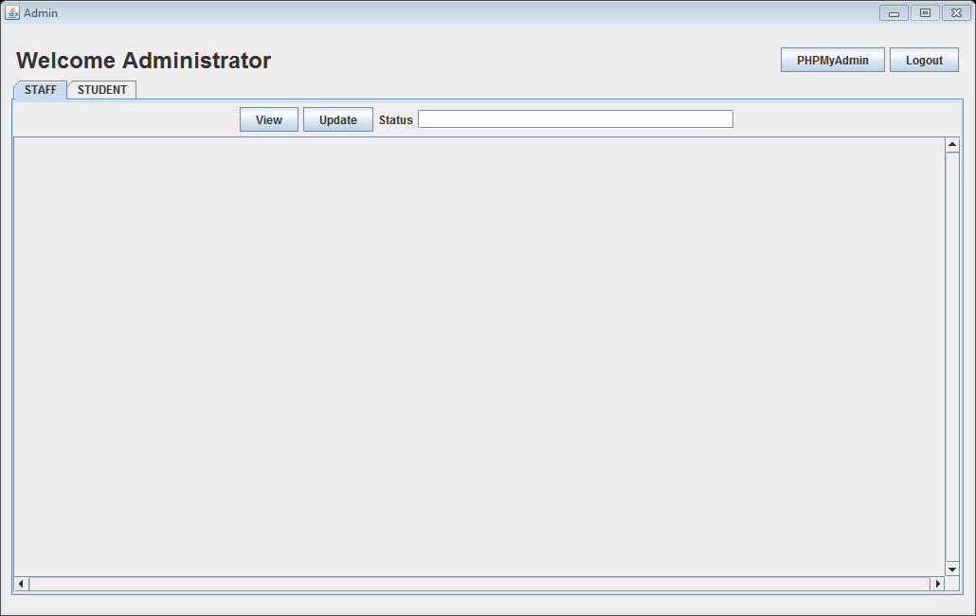

# Test 18

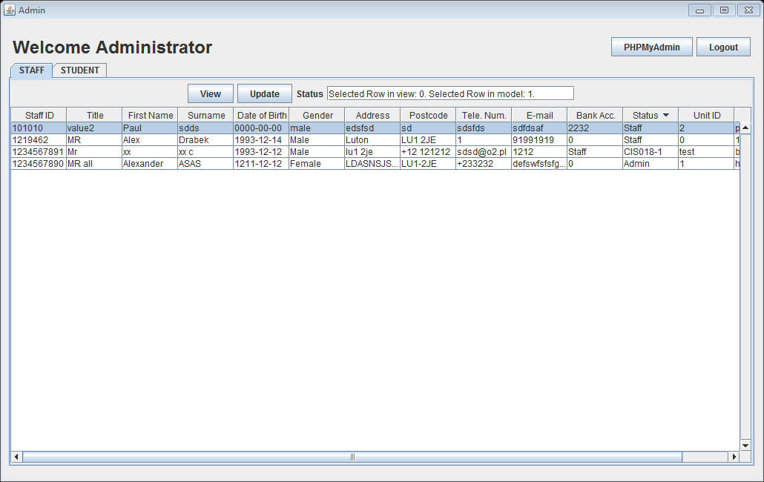

# Test 19

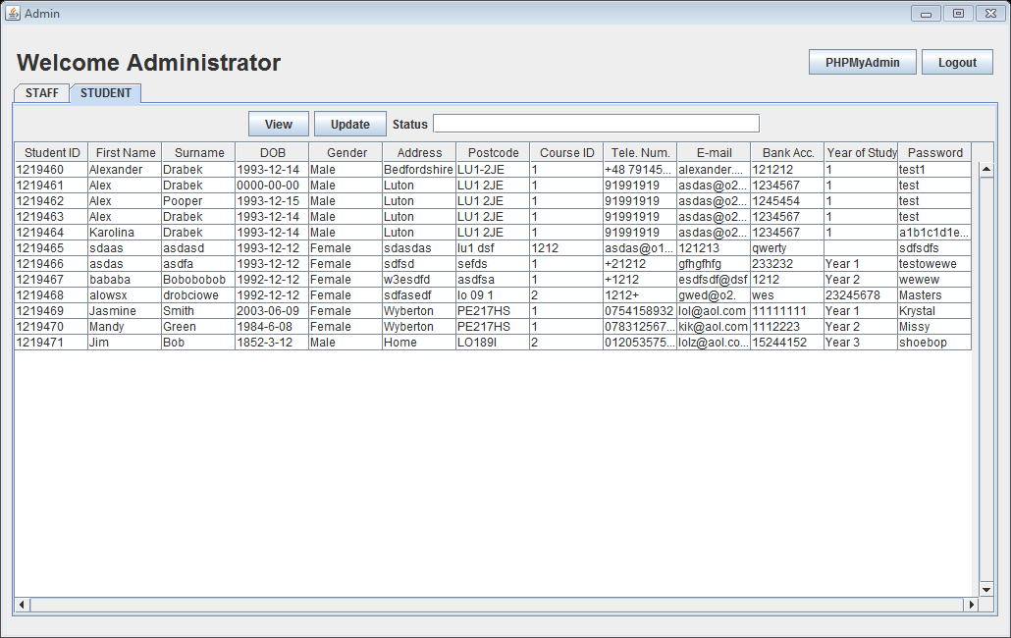

# Test 20

Database

Admin GUI

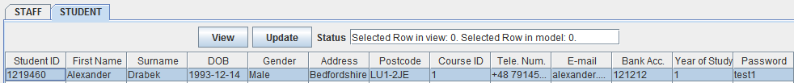



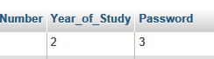

# Screen ClippingScreen ClippingTest 21A

Admin GUI



Eclipse Error!!!

# Test 21B

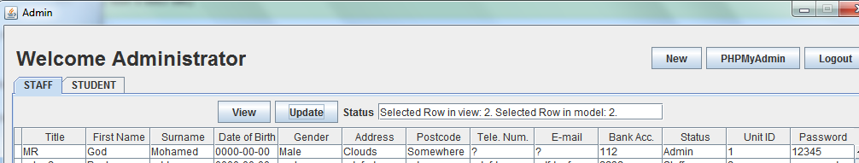

Screen Clipping

Screen Clipping

Database changed

# Test 22

Admin GUI

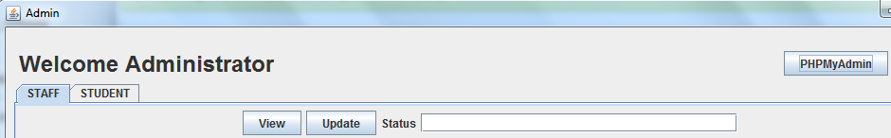

PhpMyAdmin

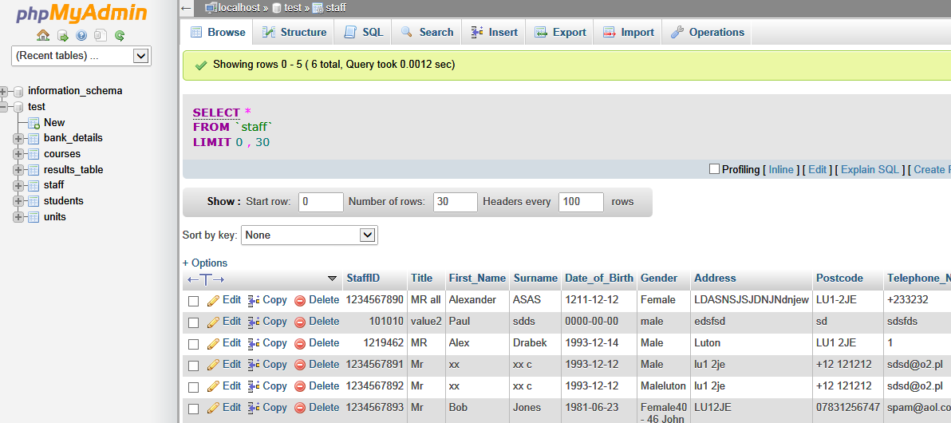

# Test 23

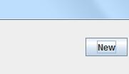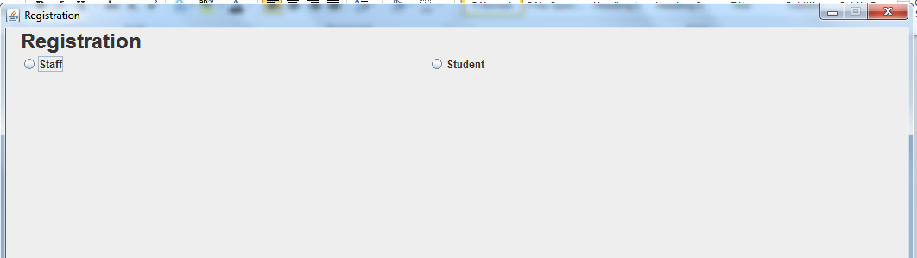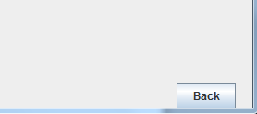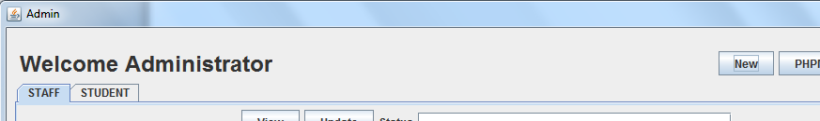

Click to enter registration page

Registration

Takes you back to admin panel